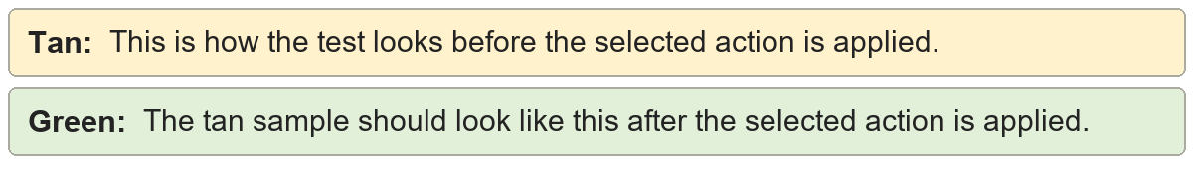
Header formatting | Shared header and footer sample.
Header formatting | Shared header and footer sample.

Footer formatting | Shared header and footer sample.
Footer formatting | Shared header and footer sample.

Header and footer font | Shared header and footer sample.
Header and footer font | Shared header and footer sample.

Header and footer spacing | Shared header and footer sample.
Header and footer spacing | Shared header and footer sample.

Header and footer alignment | Shared header and footer sample.
Header and footer alignment | Shared header and footer sample.

Unlink sections | Shared header and footer sample.
Unlink sections | Shared header and footer sample.

Clear header and footer content | Shared header and footer sample.
Clear header and footer content | Shared header and footer sample.

